**JSPM’Narhe Technical Campus**

**Subject Name:- AI and ML**

**MCA-II SEM-III**

Assignment No-3 Solve Any 6 questions

|  |  |  |  |  |  |  |  |
| --- | --- | --- | --- | --- | --- | --- | --- |
| Q.No | | Question Statement | Level of Mapping & Number | | | Blooms Level | Marks |
|  | |  | CO | PO | PSO |  |  |
| 1 | | **What Are the Different Types of Machine Learning?** | 1 | PO-2 | PSO-1 | 1 | 5 |
| 2 | | **What is ‘training Set’ and ‘test Set’ in a Machine Learning Model? How Much Data Will You Allocate for Your Training, Validation, and Test Sets?** | 1,2 | PO-2,  PO-3 | PSO-1 | 4 | 5 |
| 3 | | **What Are the Three Stages of Building a Model in Machine Learning?** | 3 | PO-2 | PSO-2 | 1 | 5 |
| 4 | | **What is Deep Learning?** | 1 | PO-1  PO-3 | PSO-2 | 4 | 5 |
| 5 | | **What Are the Differences Between Machine Learning and Deep Learning?** | 2 | PO-2  PO-3  PO-12 | PSO-1 | 2 | 5 |
|  | 6 | **What Are the Applications of Supervised Machine Learning in Modern Businesses?** | 1 | PO-1  PO-3 | PSO-1  PSO-2 | 1 | 5 |
|  | 7 | **What is Semi-supervised Machine Learning?** | 2 | PO-2  PO-3  PO-12 | PSO2 | 5 | 5 |
| 8 | | **What Are Unsupervised Machine Learning Techniques?** | 5 | PO-2  PO-6 | PSO2 | 5 | 5 |

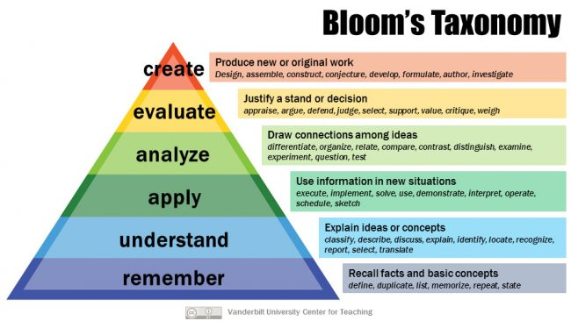

**Subject In-charge Dean**